Quick Start Guide to Completing Your BackpAQ (Version 0.89)

Ok, so you’ve built your BackpAQ device and it turns on. Now what? Here’s what to do next. This is a quick summary of the next steps…please refer to the Instructable for details and photos.

**Step 1**:

Your device powers on and the display looks like this:

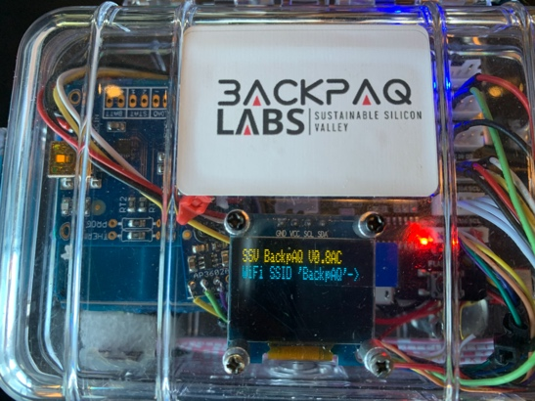 Hint: Make sure you have a charged LiPO battery!

What you are seeing at the blue line is the Wifi prompt, asking you to go to a web browser and connect via the SSID of “BackpAQ”. Once you do this a capture portal screen will appear which looks like this:

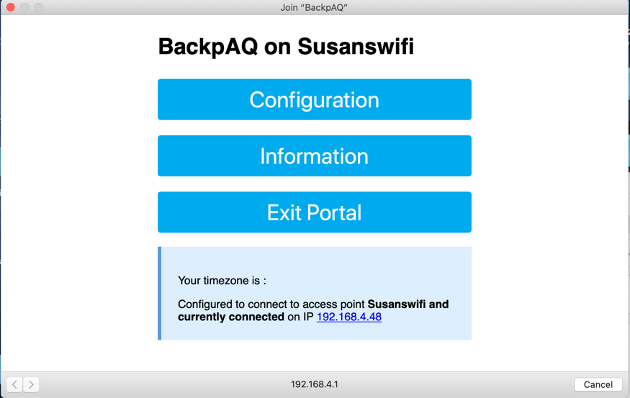 Hint: If you DON’T see this, try pressing “RESET” on the ESP board. There is code in the firmware to reset things properly if it doesn’t the first time.

Click on the top button – “Configure WiFi” and you’ll see this screen:

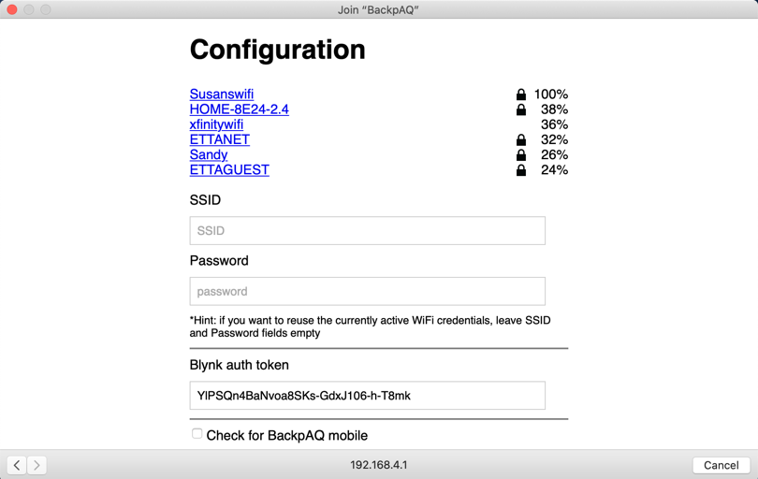 Note: This dialog will NOT work with a challenge screen like that found at places like Starbucks.

Config will show you a list of all WiFi SSIDs BackpAQ can “see”. Select the one you wish to associate you’re your BackpAQ device and type in the password. Next, you’ll need to enter your Blynk auth token, specify mobile or fixed location monitoring, enter an optional GPS lat and lon, and finally Thingspeak channels and write API keys:

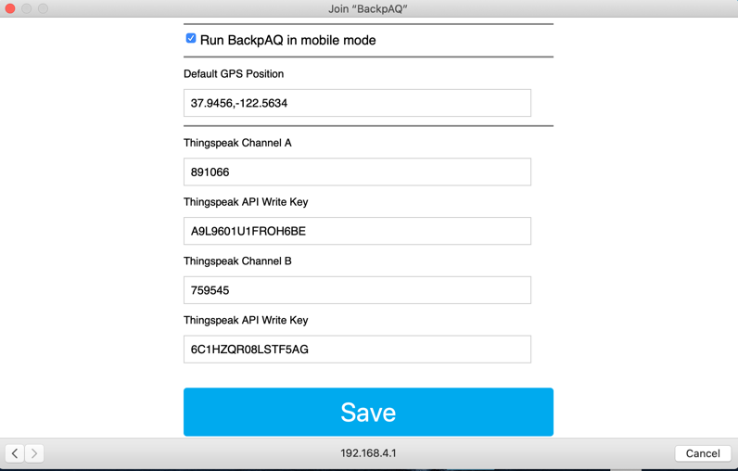

Once done, and saved, then congrats, you’re connected, and you should see this on your BackpAQ display:

This display starts a 35 second timer, to give the PM sensor some time to “warmup” (stabilize). When the timer is up, you should see this on the display:

If you are seeing this, your device is fully functional and you are getting reading from the sensor. Congrats again, you’ve completed Step 1 and are ready to complete the configuration steps of sending data to your smartphone, and then sending the data to the Thingspeak cloud.

**FOR ADVANCED STUDENTS**

If you don’t see something like this, we’ll have to do a bit of debugging to see what’s gone wrong. Once thing to try first is updating your BackpAQ firmware. To do this, you need to start up Arduino, grab the latest code from my github site (backpaq.com/drewcssv/backpaq), then flash to your device. Two things to remember before starting the flash onto your device:

1. You need to unplug the sensor Grove connector from the socket during the Upload, as it interferes with the flash process
2. You’ll need to press the “Flash” button on the ESP board during the UPLOAD to tell the board that you want to FLASH and not RUN (default is RUN mode)

**IF YOU DON’T FEEL COMFORTABLE DOING THIS**

If you’re not all that into Arduino and don’t feel up to this step, ask one of your classmates who deals with Arduino to help you with the FLASH update and debugging. I am also available most evenings on Discord and am glad to help you get going.

Once you’ve updated the firmware, try the startup sequence again. Sometimes you may need to press the “RESET” button on the ESP board to trigger the correct boot up sequence. Nothing wrong here, just a quirk of this particular ESP board.

**Step 2**

Next we’ll clone the BackpAQ app into your own smartphone. To start this step you’ll need a couple of items:

1. the QR code from the latest BackpAQ app
2. the Blynk app downloaded to your smartphone ([www.blynk.io](http://www.blynk.io))

Once it has installed, open the app and either log in or create a new account. After creating an account or logging in you will see the following screen for “New Project”:

Notice the QR-looking icon in the upper-right corner. You’ll click on this in a minute.

And here is the QR code you’ll need:

OK, now that you’re set up with Blynk, click on the

icon and point the camera on your smartphone to the above QR code.

You should see a screen like this pop up next:

To run the BackpAQ app you’ll need about 8700 energy units. I say about because it seems to vary a small amount from phone to phone. Blynk uses the Apple App Store and Google Play Store for purchasing energy, so if you select “Buy” it will draw from your Apple or Google account.

Once you have enough energy (it may take 1 or 2 purchases) the BackpAQ app should pop up, and look like this (minus the data which hasn’t been populated, of course!)

Once you have this displayed, we need to configure the BackpAQ firmware with the unique Blynk “auth” code from your new project. To do this, click on the “hex nut”

icon to display “Project Settings. You’ll see a screen like this:

Notice the Auth Token about 2/3 of the way down. You’ll need to email this to yourself to later paste into the BackpAQ Config Portal. So click on “E-mail” and Blynk will send it to you (remember to download from email so you’ll have it handy!)

**(Optional) Modifying and re-compiling the BackpAQ code**

There may be important reasons to need to recompile and re-flash the BackpAQ code. But first check to make sure you have the required set of libraries installed in the Arduino IDE. If you haven’t done this already (see Instructables for detailed instructions on how to do this), either use the Arduino “Library Manager” to locate and install the libraries or download them individually from Github and Blynk.io, installing manually (remember to close and re-open Arduino after copying in to the IDE any libraries.) Here’s the list of libraries needed to recompile BackpAQ:

#include "config.h" // config file make config changes here

#include <ESP8266WiFi.h>

#include <DNSServer.h> //Local DNS Server used for redirecting all requests to the configuration portal

#include <ESP8266WebServer.h> //Local WebServer used to serve the configuration portal

#include <WiFiManager.h> //https://github.com/tzapu/WiFiManager WiFi Configuration Magic

#include <DoubleResetDetector.h> //https://github.com/datacute/DoubleResetDetector

#include <BlynkSimpleEsp8266.h>

#include <Adafruit_GFX.h>

#include <Adafruit_SSD1306.h>

#include <Arduino.h>

#include <Adafruit_BME280.h>

#include <widgetRTC.h>

#include <TimeLib.h>

Once you’re set with Blynk and other dependencies it’s time to compile and upload the code to your BackpAQ device. As I mentioned in Step 1, you need to grab the latest code (V0.85) from my github site (backpaq.com/drewcssv/backpaq. Three things to remember before starting the Upload:

1. You need to unplug the sensor Grove connector from the socket during the Upload, as it interferes with the flash process
2. You will need to unscrew the two screws that secure your ESP board to the case. Sorry about that ;-), but it’s the only way to get access the micro USB you need to connect to your laptop
3. You’ll need to press the “Flash” button on the ESP board during the UPLOAD to tell the board that you want to FLASH and not RUN (default is RUN mode)

Go ahead and perform the Upload to your device, remembering to press “Flash” button to trigger the flash mode. You may have to press more than once or hold it down to get the board’s attention.

Once the upload is finished you can re-plug the sensor connector and re-fasten the two standoff screws that hold your ESP board in place. On to the final part of this step.

OK, having re-flashed the BackpAQ device you are ready to test the connectivity to your smartphone. Here’s what we need to do:

1 Power up BackpAQ device, pressing RESET button to reboot properly after the UPLOAD operation. You should see the WiFi prompt as sown here:

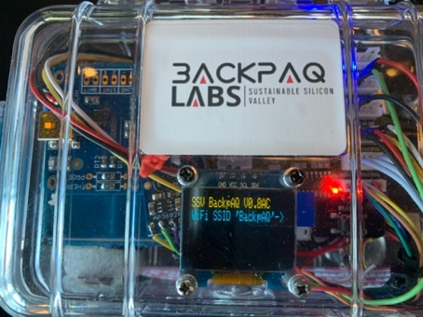

Log in to your WiFi of choice as discussed in Step 1. After 35 seconds you should see the PM data appear on your display, updating every 8-10 seconds or so.

Now, on your Smartphone, open the Blynk app and the BackpAQ app should appear:

Click on the square icon to switch from BUILD mode to RUN mode. If everything is working you should see data start appearing in the gauges, graphs and data boxes. If you see this, then woo-hoo, you have built an IOT device that talks to your phone! Time to take a break before Step 3.

**Step 3**

OK, now that we’ve got an up-to-date version of the BackpAQ firmware on our device, and the BackpAQ app up and running on your smartphone, we’re ready to test the whole enchilada.

Go ahead and power up your BackpAQ device, remembering to press the RESET button on the ESP board since we’ve just done a flash. You should see this familiar screen:

 Hint: Make sure you have a charged LiPO battery!

What you are seeing at the blue line is the Wifi prompt, asking you to go to a web browser and connect via the SSID of “BackpAQ”. Once you do this a capture portal screen will appear which looks like this:

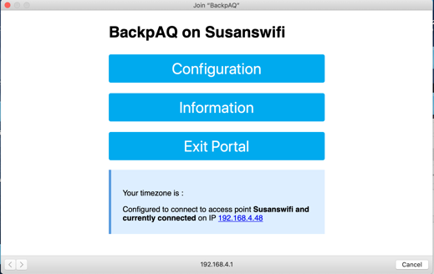 Hint: If you DON’T see this, try pressing “RESET” on the ESP board. There is code in the firmware to reset things properly if it doesn’t the first time.

Click on the top button – “Configure WiFi” and you’ll see this screen:

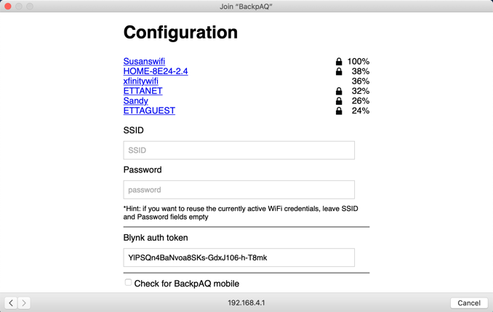

This is a list of all WiFi SSIDs BackpAQ can “see”. Select the one you wish to associate your BackpAQ device with and type in the password. Then, copy/paste (or type) in your private Blynk Token in the “BLYNK auth token” field (below):

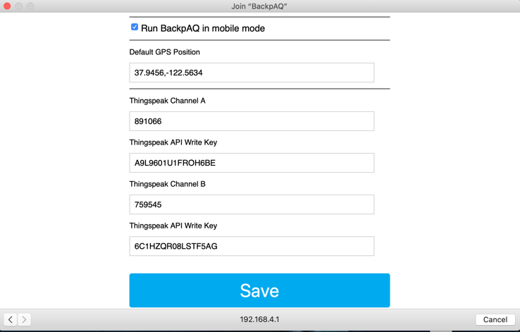

Next, check the box for “BackpAQ mobile” mode if you intend to use BackpAQ as a mobile device with your smartphone. Leave unchecked if you intend to leave the BackpAQ in a fixed place. You can also optionally enter a GPS latitude and longitude which is useful if using BackpAQ in a fixed location and away from your smartphone.

Finally, copy over the Thingspeak channel IDs and associated API Write Keys. Then hit “Save”.

Congrats, you’re connected, and you should see this on your BackpAQ display:

This display starts a 35 second timer, to give the PM sensor some time to “warmup” (stabilize). When the timer is up, you should see this on the display:

If you are seeing this, your device is fully functional and you are getting reading from the sensor. Congrats again, you’ve completed Step 3 and are ready to complete the configuration step 4, sending data to the Thingspeak cloud.